Table of Contents
1. Executive Summary 2
1 Introduction (approx.. 1-2 pages) 3
1.1. Purpose and scope of the document 3
1.2. Relation to Work Packages, Deliverables and Activities 3
1.3. Structure of the Document 3
2 Dissemination and Communication Strategy (approx. 10 pages) 4
2.1 Objectives 4
2.2 Dissemination & Communication roadmap 4
2.3 Roles & Responsibilities 4
2.4 Target groups 5
2.5 Assets to disseminate 5
3. Means & activities to raise Awareness of CoEvolution (approx. 15 pages) 6
3.1. Dissemination and Communication Toolkit 6
3.1.1. Web presence and digital material 6
3.1.2. Printable Material 6
3.2. Planned Dissemination and Communication Activities 6
3.2.1. Publications 6
3.2.2. Events 7
3.2.2.1. Events organised by the consortium 7
3.3. Funding information 7
3.4. Collaboration with other projects and initiatives 8
4. Monitoring – KPI’s (approx. 5 pages) 9
5. Exploitation Plan 10
6. Conclusion (approx.. ½ page) 11

Executive Summary
The "Plan for Impact Delivery" of the CoEvolution project outlines a comprehensive strategy designed to ensure the successful realization of the project's objectives and its lasting impact. This deliverable sets the foundation for impactful engagement with key stakeholders and aims to establish a clear path for the project's results to resonate within relevant communities and industries.
A key focus of this plan is dissemination and communication. The document provides a well-structured communication strategy with precise goals and targeted approaches. This strategy has been developed to effectively deliver the project's outcomes to the appropriate audiences, using a diverse range of dissemination and communication tools and techniques. These include both digital and traditional channels, tailored to reach the various stakeholders relevant to CoEvolution.
The deliverable also integrates a robust monitoring and evaluation framework, essential for assessing the success of dissemination activities. Key Performance Indicators (KPIs) have been established to track the effectiveness of outreach efforts, ensuring that the dissemination and communication strategy evolves in line with project progress. This monitoring approach allows for agile adjustments, guaranteeing that the CoEvolution project achieves its intended impact.
Additionally, the document offers an early review of progress up to M06, providing a snapshot of key milestones reached and setting the stage for subsequent phases of the project.
In addition to the dissemination and communication strategy, the "Plan for Impact Delivery" also integrates an Exploitation Plan, which outlines the mechanisms through which the CoEvolution project’s results will be maximized for long-term impact.
The exploitation plan defines the key approaches and actions that will be undertaken to drive the uptake of CoEvolution’s results, including strategies for intellectual property (IP) management, commercialisation of outcomes, and fostering collaborations with external stakeholders. It also highlights the importance of sustainability, ensuring that the project’s outcomes continue to create value beyond its duration.

Introduction (approx.. 1-2 pages)

Purpose and scope of the document
The "Plan for Impact Delivery" of the CoEvolution project is designed to strategically guide the effective communication, dissemination, and exploitation of the project’s outcomes. It outlines the strategic framework for delivering impactful results throughout the CoEvolution project. It defines the key actions, goals, and strategies for disseminating and exploiting the project's findings, ensuring they reach the appropriate audiences and contribute to the advancement of knowledge and practical solutions. By setting clear objectives and defining specific roles, it provides the structure for maximizing the project's influence and facilitating the uptake of its results.
The objectives of this document are as follows:
- Defining a comprehensive communication and dissemination strategy that will guide the CoEvolution project’s activities and ensure alignment with its goals.
- Clarifying roles and responsibilities of all partners involved in dissemination and exploitation to guarantee effective collaboration.
- Identifying suitable channels and tools for communicating results, using both digital platforms and traditional mediums to reach the target audiences.
- Establishing a methodology for monitoring and evaluating the impact of dissemination efforts, allowing for continuous improvement and ensuring the project’s success.
- Detailing exploitation pathways for the project’s outcomes, focusing on integrating results into commercial, policy, and further research initiatives.
Through the delivery of this document, the CoEvolution project aims to develop a comprehensive communication and dissemination strategy that will enable it to achieve its objectives and have a significant impact on the target audiences. By effectively engaging with stakeholders and sharing its research findings, CoEvolution strives to contribute to the advancement of science and promote innovation in its field.

Relation to Work Packages, Deliverables and Activities
This deliverable is directly connected to the project's activities and results. It is relevant across all work packages. WP3, WP4, WP5, and WP6 contribute the content to be disseminated, generating the knowledge that the consortium aims to share with the target audience.

Structure of the Document
Leader: AEGIS
In this section AEGIS will provide the several subsections or chapters of the document

Dissemination and Communication Strategy
In this section, AEGIS will provide the objectives of a Dissemination & Communication strategy of a project and describe the planned actions and techniques for effectively disseminating the project’s findings.
2.1 Objectives
This strategy will outline how CoEvolution's results will be shared with the relevant stakeholders at the right time and through the most suitable channels. The main objectives of the dissemination and communication strategy are as follows:
- Ensure that all partners understand the role of dissemination and communication in supporting the CoEvolution project’s overall objectives.
- Establish a strong, recognisable project identity that will be consistently reflected in all communication materials. A professional toolkit, including promotional and informational materials, will be developed to support this.
- Raise awareness of the project's goals, progress, and outcomes among key stakeholders, including researchers, industry professionals, and policymakers.
- Increase the project's visibility within relevant communities and the broader public, thereby amplifying its impact and fostering greater recognition.
- Ensure the effective transfer of knowledge generated by the project, making it accessible, clear, and practical for the target audience to maximise its impact.
- Engage and foster collaboration among stakeholders by involving them in project activities, building support, and generating sustained interest.
- Simplify and clearly present the project's value proposition to ensure it can be easily understood by both project partners and external stakeholders, particularly those not directly involved in the project.
- Plan and produce articles and scientific publications to disseminate project results at relevant conferences and through respected scientific journals, adhering to best practices for academic communication.
The CoEvolution dissemination and communication strategy should be designed to be flexible and adaptable to changes in the project's scope, objectives, and outcomes. This approach will ensure that the project remains relevant and impactful throughout its lifecycle.
To achieve these objectives, a series of well-coordinated actions will be undertaken. These actions must be aligned with the progress of the project to ensure that they are timely and impactful. To achieve an effective dissemination approach, the consortium has identified several principles that need to be considered:
- Accessibility, adaptability, and diversity of information: Dissemination activities will be continuously updated and tailored to meet the diverse needs of different audiences. This ensures that the information is accessible and engaging for various stakeholders.
- Relevance and clarity of the information: All information shared will be tailored to the specific needs and understanding of each user group, ensuring that it is both relevant and comprehensible, maximising its impact.
- Engagement with end-users: Interacting with end-users and gathering feedback will be central to the dissemination and communication strategy. Understanding their needs and concerns will allow the project to ensure that its communication efforts are effectively aligned with user expectations and project achievements.
2.2 Dissemination & Communication roadmap
To achieve the project objectives with regards to dissemination, the dissemination and communication strategy will adhere to the phases depicted in Figure 1
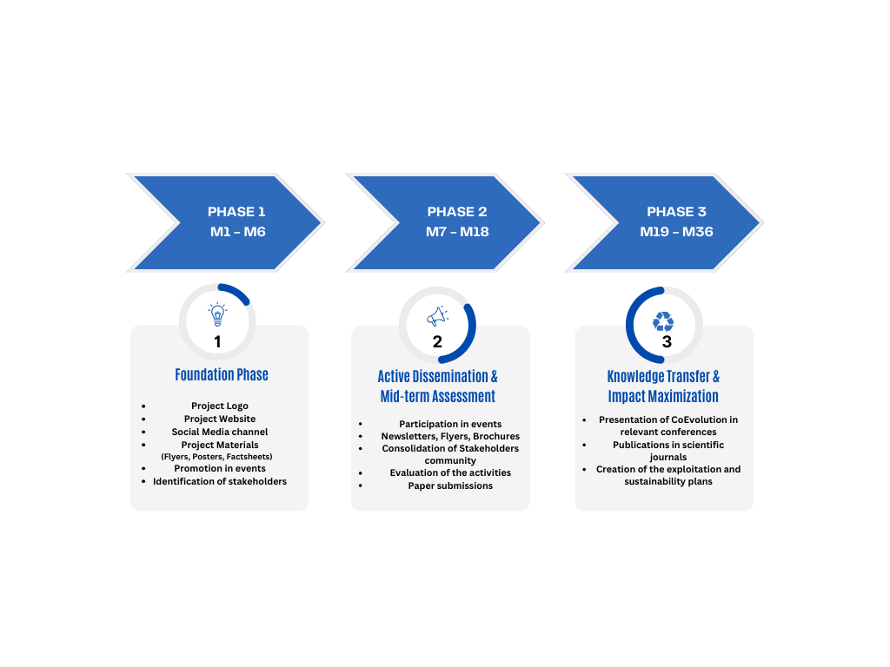
Figure 1 - Dissemination & Communication Strategy phases

Phase 1: Foundation Phase (M1 – M6)
During this initial phase, we focus on developing a comprehensive communication and dissemination strategy for the CoEvolution project. This phase is essential as it involves creating a structured roadmap that defines specific activities and actions to be implemented throughout the project’s lifecycle. By establishing this foundation, we ensure a well-organized approach that effectively supports the project's objectives.
The communication and dissemination strategy outlines key elements such as project objectives, target audiences, core messages, preferred communication channels, and realistic timelines. This detailed planning ensures that dissemination efforts are strategically aligned with the project’s goals and effectively reach the intended stakeholders.
Once the strategy is finalized, we initiate the deployment of communication tools, including the launch of a dedicated project website, the creation of social media channels, and the development of outreach materials such as newsletters and social media content. These actions bring the strategy into operation, fostering engagement with the target audiences from the early stages of the project.
By the end of Month 6, this phase will be successfully completed, with a solid communication and dissemination framework in place. The established roadmap will ensure that all activities are well-coordinated and contribute to achieving the project's impact objectives throughout its duration.
Table 1 - Foundation Phase – Key D&C actions roadmap
Action | Timeline | Status
CoEvolution Website | TBA | Completed (See https://coevolution-project.eu/)
Set-up X Account | M3 | Completed (See https://x.com/coevolution_eu)
Set-up LinkedIn Account | M3 | Completed (See https://www.linkedin.com/company/106186299)
Set-up Facebook Account | M3 | Completed (See https://www.facebook.com/profile.php?id=61572810781073)
Set-up Bluesky Account | M3 | Completed (See https://bsky.app/profile/cpaid-euproject.bsky.social)
Set-up YouTube Channel | M3 | Completed (See https://www.youtube.com/@CoEvolutionEUH2020)
1st Press Release | M5 | In Progress
1st Introductory Video | M6 | In Progress
The first CoEvolution Newsletter | M6 | In Progress
The current document D2.1 | M6 | In Progress

Phase 2: Active Dissemination & Mid-term Assessment (M7 – M18)
During this phase, the focus shifts towards actively engaging stakeholders and expanding the reach of the CoEvolution project. With the communication and dissemination framework established, efforts are now directed at raising awareness, fostering dialogue, and ensuring that key messages resonate with the target audiences. A variety of dissemination activities will be deployed to effectively engage stakeholders, including targeted workshops, interactive webinars, industry events, and direct meetings. These initiatives will serve as essential platforms for sharing project insights, discussing key developments, and gathering valuable feedback from stakeholders. Additionally, scientific publications, blog posts, and social media campaigns will be leveraged to amplify the project's visibility.
This phase also includes the First Impact Analysis (M18), which will provide an initial evaluation of the project's outreach effectiveness. Insights gathered from stakeholder engagement and dissemination activities will be assessed to refine the strategy, ensuring continuous improvement and alignment with project goals.
Table 2 - Active Dissemination & Mid-term Assessment - Key D&C actions roadmap
Action | Timeline | Status
Technical Workshop | M10-M12 | Not Started
1st InfoDay (Webinar) | M12 | Not Started
Summer school | M12 – M18 | Not Started
Online Training Tutorial | M14 - M18 | Not Started
Industrial Panel | M14 - M18 | Not Started
D2.2 First Impact Analysis | M18 | Not Started
Phase 3: Knowledge Transfer & Impact Maximization (M19 – M36)
In this phase, the primary goal is to actively promote the adoption and deployment of the tools, concepts, and methodologies developed by the CoEvolution project. Recognising the importance of these innovations, focused promotional activities will be carried out to effectively communicate their value and potential to the broader community.
By the 18-month milestone, the project will have generated concrete outcomes. This marks a crucial point where the dissemination and communication plan is updated. This updated plan will expand efforts to engage a wider audience, including potential users, industry stakeholders, and policy makers, while adapting strategies to address the evolving needs of the market. The revised communication and dissemination strategy will emphasize not only the promotion of CoEvolution’s outcomes but also the support for their exploitation. By ensuring that the project's innovations are effectively disseminated and deployed, this phase aims to create a lasting impact that drives growth, fosters collaboration, and sustains innovation in the relevant fields.
Additionally, the Final Impact Report (M36) will assess the project's success in achieving its dissemination goals and will provide a comprehensive overview of the outcomes, highlighting the long-term effects of CoEvolution's contributions.
Table 3 - Knowledge Transfer & Impact Maximization - Key D&C actions roadmap
Action | Timeline | Status
2nd InfoDay (Webinar) | M19-M22 | Not Started
Use Case workshop | M20 -M24 | Not Started
Technical Workshop | M20 -M26 | Not Started
Online Training Tutorial | M20 -M26 | Not Started
Summer School | M20 – M26 | Not Started
Industrial Panel | M20 – M26 | Not Started
Use Case workshop | M24 – M26 | Not Started
Online Training Tutorial | M26 -M30 | Not Started
Industrial Panel | M30– M36 | Not Started

Roles & Responsibilities
To ensure the effective dissemination and communication of the CoEvolution project, all project partners will be actively involved in dissemination and communication efforts, collaborating to ensure the project's outcomes and achievements reach the relevant stakeholders and audiences. Each partner's contribution will be essential in maximizing the project's impact, with roles tailored to their individual expertise, market position, and resources. Partners will leverage their strengths, networks, and industry connections to target specific audiences and ensure that CoEvolution's outcomes are communicated effectively and exploited efficiently. By drawing on their diverse capabilities, partners will enhance the reach and visibility of the project, ultimately fostering greater adoption of the innovations developed.
Table 4 outlines the specific roles and responsibilities of each partner, taking into consideration their geographic presence, industry influence, and area of expertise. This distribution of responsibilities will ensure that all partners are aligned with the project's objectives and are positioned to contribute in the most effective way to the dissemination and communication strategy.
Table 4 – Individual dissemination and communication plans
CoEvolution Member | Role and responsibilities regarding dissemination and communication
ICCS
ISI
UNICA
SIE
AEGIS | AEGIS, in its role as the Dissemination Manager, will lead all dissemination activities for the CoEvolution project, ensuring the creation and distribution of high-quality, impactful materials. By following the CoEvolution dissemination plan, AEGIS will use its network of stakeholders and its communication channels to maximize project visibility and engagement. This includes leveraging the AEGIS website, social media platforms, and blogs to share project updates, insights, and results. Furthermore, AEGIS will actively participate in key EU events, conferences, and trade fairs, ensuring that the project’s outcomes are highlighted and shared with relevant audiences across Europe.
TID
UNIPI
SLC
AVL
AVI
DIE
CBRL
STS
BEVD
Upatras

Target groups
To effectively evaluate the success of the CoEvolution project, it is crucial to establish well-defined Key Performance Indicators. A tailored dissemination and communication strategy for each target group is essential to effectively reach and engage with the relevant stakeholders. Below is a plan for each identified target group based on the specific needs and interests they hold in the context of AI and security.
1. AI Researchers and Developers
- Objective: Provide tools and frameworks to build secure, robust, and trustworthy AI systems.
- Communication Channels: Webinars, academic journals, and research conferences.
- Tailored Messaging: Highlight CoEvolution’s role in improving adversarial robustness and security in AI models.
- Engagement Activities: Organise research-focused workshops, collaborate on academic papers, and provide resources on AI security frameworks.
2. Security Professionals and Researchers
- Objective: Enhance security-by-design and resilience against adversarial attacks in AI systems.
- Communication Channels: Specialised cybersecurity events, online forums, and industry seminars.
- Tailored Messaging: Stress CoEvolution’s contribution to securing AI-based systems in network security.
- Engagement Activities: Host training sessions, develop case studies on adversarial defense, and engage in collaborative research projects.
3. Government and Regulatory Bodies
- Objective: Support the establishment of standards for evaluating AI-based security systems.
- Communication Channels: Policy roundtables, regulatory webinars, and reports.
- Tailored Messaging: Emphasise the importance of adversarial robustness in AI regulations and security standards.
- Engagement Activities: Provide policy briefs, contribute to AI regulation discussions, and consult on the integration of security standards in AI systems.
4. Technology Companies
- Objective: Assist companies in securing their AI supply chains and ensuring data integrity.
- Communication Channels: Industry conferences, business roundtables, and newsletters.
- Tailored Messaging: Show how CoEvolution’s framework ensures secure, interoperable, and trustworthy AI solutions.
- Engagement Activities: Offer consultations on AI security, conduct targeted demonstrations, and collaborate on joint projects.
5. Software and Hardware Vendors
- Objective: Address the need for secure and resilient technologies in AI hardware and software.
- Communication Channels: Product webinars, technical demonstrations, and trade shows.
- Tailored Messaging: Showcase how CoEvolution’s solutions enhance the security and resilience of AI-based hardware and software.
- Engagement Activities: Organise technical workshops for vendors, provide use cases for secure hardware, and facilitate collaboration on resilient solutions.
6. Industry and Business Leaders
- Objective: Demonstrate the value of context-aware, resilient AI systems for businesses.
- Communication Channels: Business forums, CEO roundtables, and industry newsletters.
- Tailored Messaging: Highlight how CoEvolution’s approach ensures more robust and resilient AI applications for businesses.
- Engagement Activities: Collaborate with industries, host roundtable discussions with technical managers, deliver tailored presentations, and provide industry-specific case studies.
7. End Users of AI Systems and General Public
- Objective: Raise awareness of AI systems' security and trustworthiness.
- Communication Channels: Public webinars, blogs, social media, and user-friendly reports.
- Tailored Messaging: Emphasise CoEvolution’s role in ensuring AI systems is safe, ethical, and reliable for everyday users.
- Engagement Activities: Conduct public awareness campaigns, provide easy-to-understand guides, and create interactive tools to demonstrate AI security.
8. Policy Makers
- Objective: Support the development of AI governance frameworks and security standards.
- Communication Channels: Policy briefings and European forums.
- Tailored Messaging: Advocate for AI security and ethical guidelines, referencing CoEvolution’s impact on trustworthy AI.
- Engagement Activities: Provide insights through policy papers, participate in regulatory consultations, and collaborate on policy development.
To ensure the continuous improvement and effectiveness of the tailored communication strategies outlined above, a robust evaluation and optimisation framework is essential.
- Feedback Mechanisms: Implement feedback mechanisms to solicit input from stakeholders and evaluate the effectiveness of communication strategies, adjusting approaches as needed to optimise engagement and impact.
- Metrics and Performance Indicators: Define KPIs and metrics to track progress towards engagement goals and measure the impact of communication efforts across different stakeholder groups.

Means & activities to raise Awareness of CoEvolution (approx. 15 pages)
Leader: AEGIS
In this section, AEGIS will provide the tools, materials, and activities that will be used to carry out the dissemination and communication plan

Dissemination and Communication Toolkit

Web presence and digital material

Project logo

Project Website

Social Media accounts

Newsletters

Blog articles

Printable Material

Planned Dissemination and Communication Activities

Publications
Leader: AEGIS, Contributors: All
In this section (In the following table), each partner should list the name of the specific scientific journal or conference where they plan to submit their findings
Table 5 - Indicative targeted scientific publications
Journal/ Conference/ Workshop | Partner

Events
Leader: AEGIS, Contributors: All
This section will include information about any events or activities that will be organised or co-organised by the consortium partners as part of the project.

Events organised by the consortium
Contributors: All
This section will include details about any events or activities that are planned or being organised by the consortium

Event organised by the partners of the consortium
Contributors: All
The partner that intends to organise an event should include a brief description of the event, highlighting its purpose, objectives, and relevance to the project. Explain how the event aligns with the project's goals and contributes to its overall objectives.

Funding information
Leader: AEGIS
AEGIS will provide the requirement for all dissemination materials related to the project and any infrastructure, equipment, and major results

Collaboration with other projects and initiatives
Leader: ISI
This section will outline the other projects and initiatives that our project intends to reach out to.

Monitoring – KPI’s (approx. 5 pages)
Leader: AEGIS
AEGIS will provide details on the Monitoring-KPIs that are essential to measuring the progress of the CoEvolution project. This section outlines the Key Performance Indicators that will be used to evaluate the success of the project's communication and dissemination strategy. Additionally, it discusses the means that will be employed to measure the progress of the project
  - Key Performance Indicators
  - Means to measure progress

Exploitation Plan
Leader: AVL

Conclusion (approx.. ½ page)
Leader: AEGIS
In this section AEGIS will provide a conclusion of the deliverable and an overview of the short term future plan.

